**Chat Hangout Documentation**

**1- Hangout application user guide**

The hangout App is a great tool for students to communicate with their peers and discuss course related topics outside class in a more casual environment.

Being inquisitive is a major asset for success. This platform comes in an effort to give the students that are interested in the topic the opportunity to expand their knowledge and expose them to new ideas, and to those that are more experience the opportunity to rethink the course concepts and understand them further.

The Google Hangouts page is only accessible for authenticated users. In addition, the student would have to be enrolled in at least one course in order to use the app.

Before signing up for a class the user Hangouts pages is empty

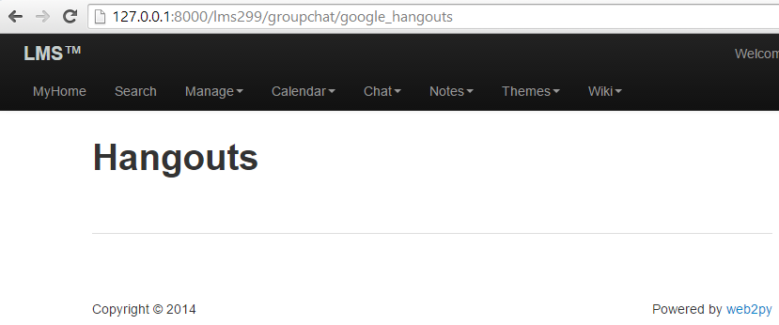

First, the user needs to enroll in a class.

If you wish to enroll in a particular course, go to the */default/index* page, and click one of the available courses.

In this example I will select [CSC255](http://127.0.0.1:8000/lms299/default/section/111)

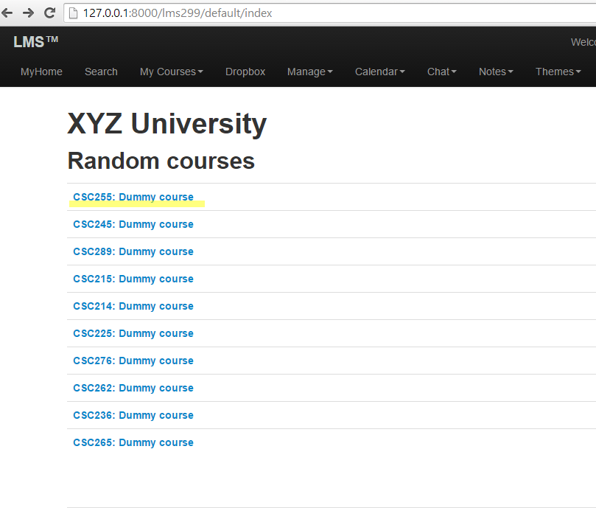

Then click the lick highlighted in yellow

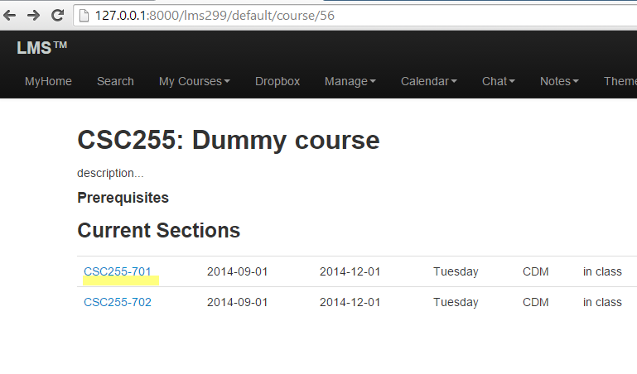

Then click “**Sign Up for this class**”

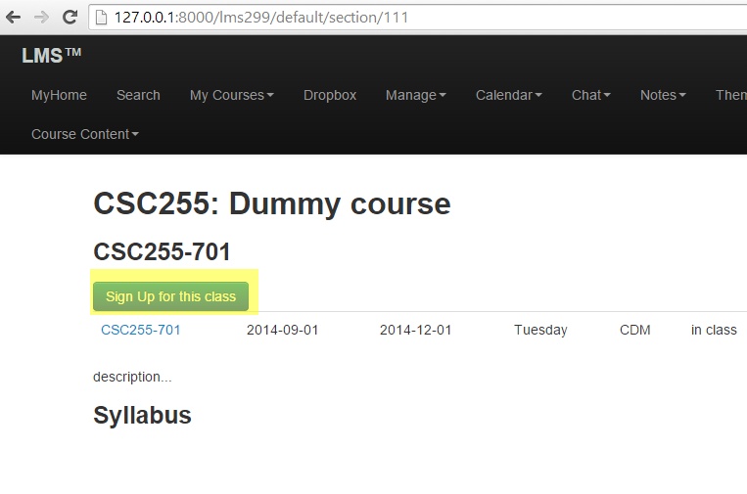

Now that the student is successfully enrolled in the [CSC255](http://127.0.0.1:8000/lms299/default/section/111) course. And the */groupchat/google_hangouts* page will now display the hangouts information related to this specific course.

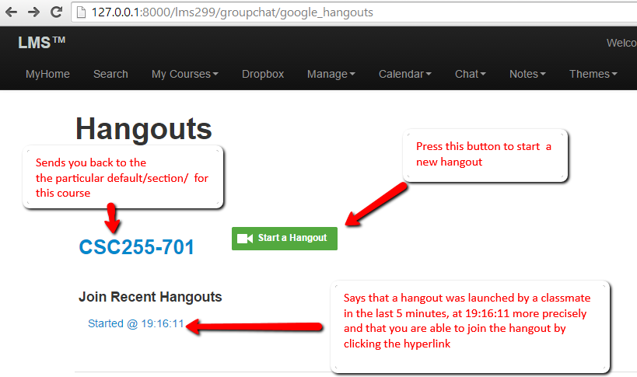

When the “**Start a Hangout**” button is pressed, the user is directed to this page.

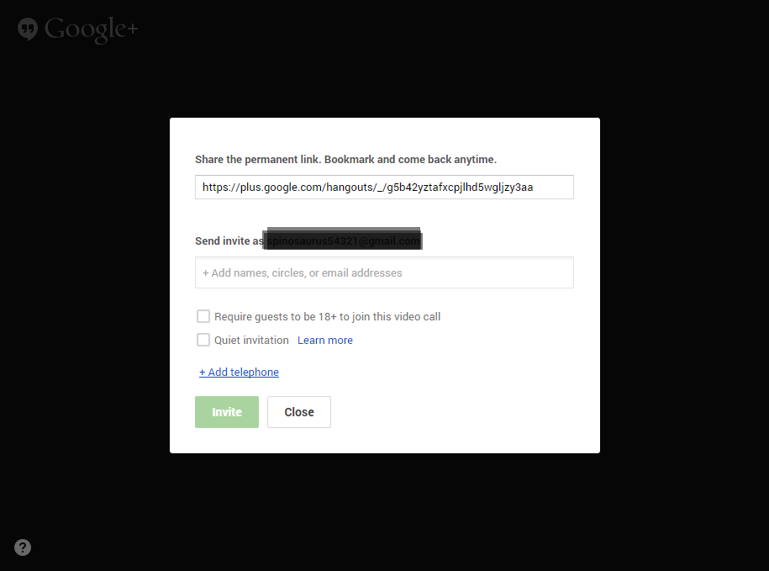

Click the “**Close**” button.

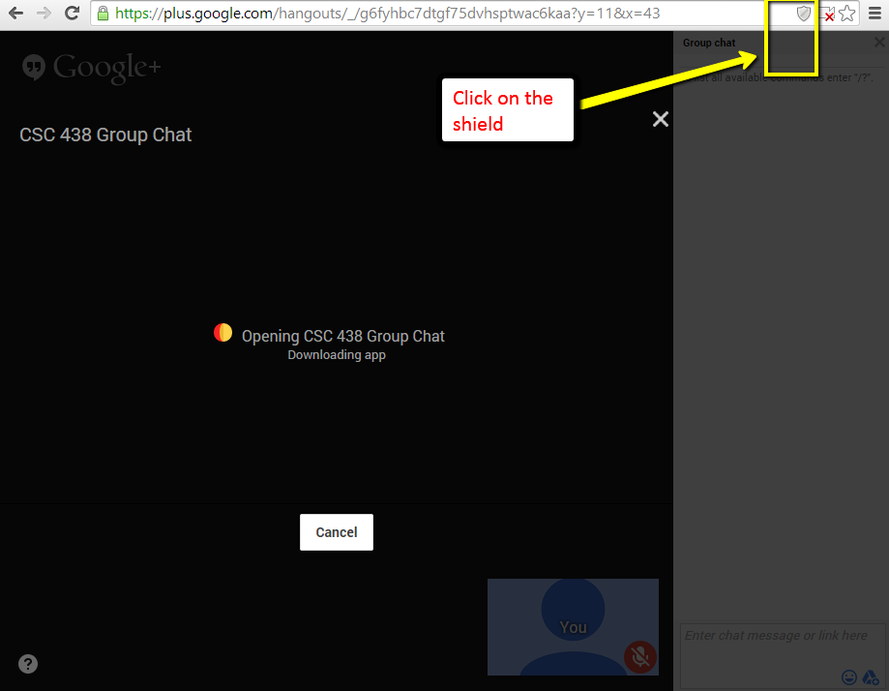

Click on the shield at the top left of the window.

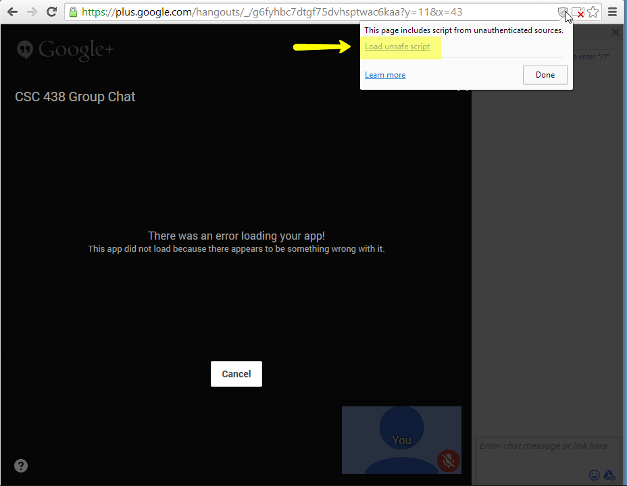

Then click “**Load unsafe script**”.

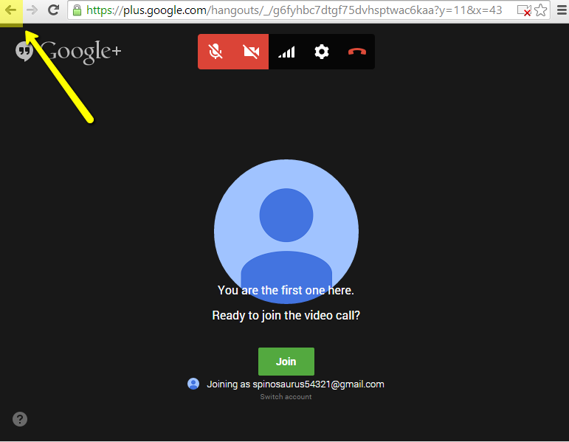

The script from the google project has now been loaded. Click the back arrow to return to the previous page.

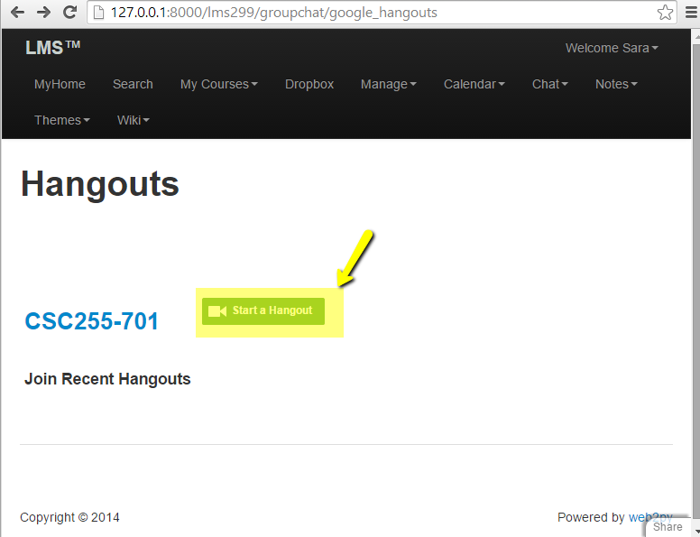

Click “**Start a Hangout**” once again on this page.

Since the script has been loaded on the page, the app will now start with the correct settings.

On the next page enter a person you wish to invite and the hangout will start right afterwards. And the groupchat/google_hangoutswill notify other people enrolled in the class that a new hangout associated with this course has been started and that provides them with the hangout link in case they want to take part.

**2- Hangout application developer guide**

Files that the chat group created or modified:

Controllers

* google_chat.js
  + def group_chat():
  + def google_hangouts():

Retrieves the courses the student is enrolled in and the urls associated with each course.

* + def hangouts_url_for_session():
  + def update_user_settings_microphone():
  + def update_user_settings_camera():
  + def insert_new_hangout(course_section_id, user_id, hangout_url):
  + def update_existing_hangout(session_id, url):
  + def history():
  + def add_user_to_chat(session_id):

Models

* menu_chat.py
  + added a dropdown menu for two pages: “History” and “Google Hangouts”
* group_chat.py defines the following tables:
  + group_chat_session
  + group_chat_user_settings
  + group_chat_user_session
  + init_group_chat_session
  + update_group_chat_session
  + add_user_to_group_chat_session
  + update_user_group_chat_settings
  + update_user_setting_mic
  + update_user_setting_cam
  + get_user_group_chat_settings
  + get_group_chat_sessions_for_user
  + get_group_chat_sessions_for_user

Static/css

* group-chat.css
* chat.css
  + contains styling for the google_hangouts page

Static/js Delete chat.js

* group_chat.js
* google_hangous.js

Static/css

* start-hangout.png